Name:__________________
Date:___________________
Period:__________________

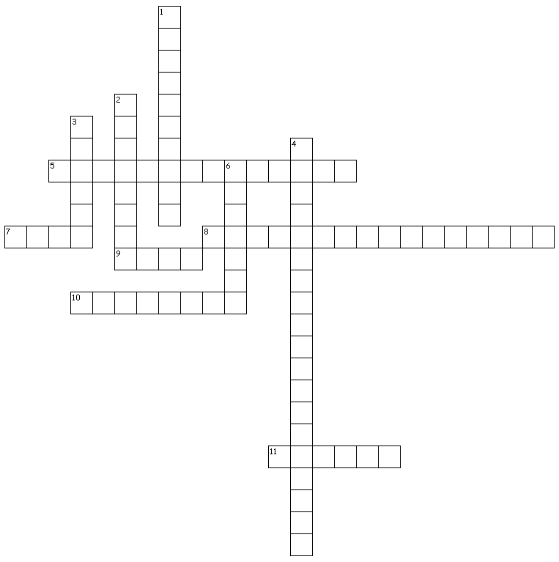
Credit Terminology Cross Word Puzzle
Across
5. security held by the lender
7. an obligation to pay
8. dollars that are owned or borrowed
9. land, buildings, fences are examples of ____ property.
10. cars, equipment and hay are examples of _____ property.
11. borrower

Down
1. property pledged as security for a loan
2. someone who extends credit
3. borrowing money promising to pay back
4. decisions about capital
6. money used to purchase goods

