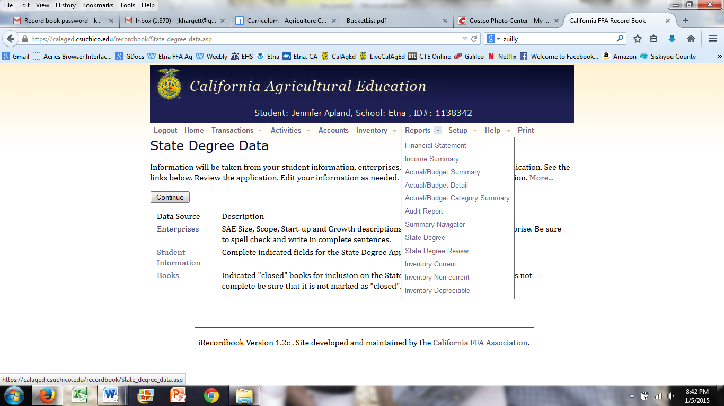
Click on state degree above
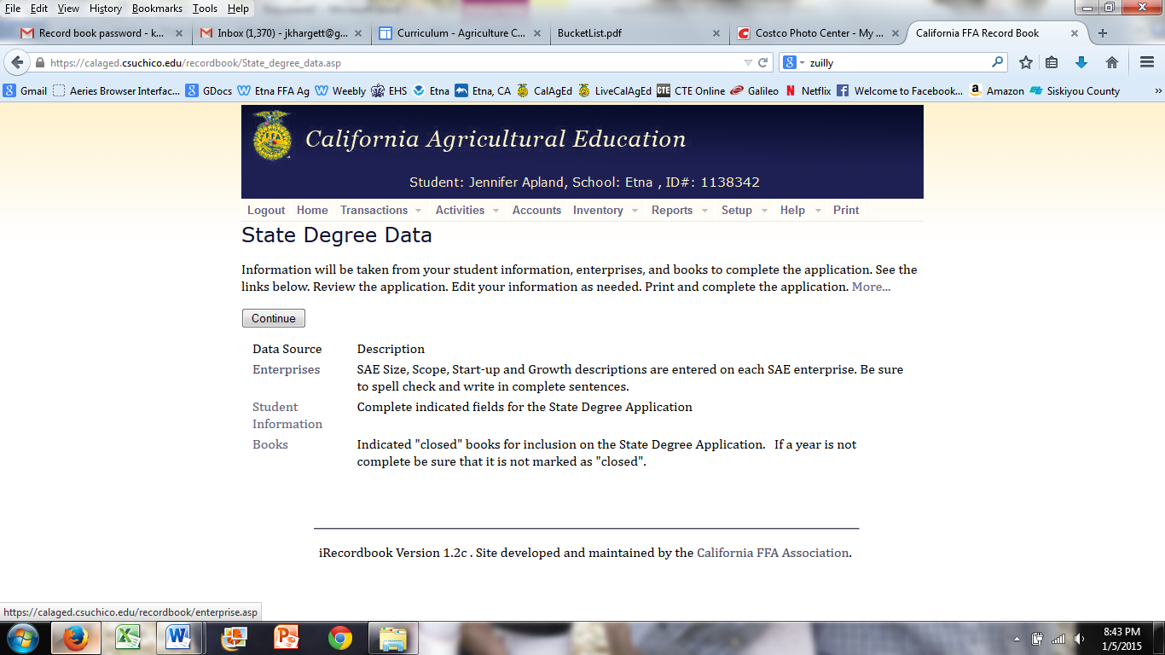
Click on enterprises
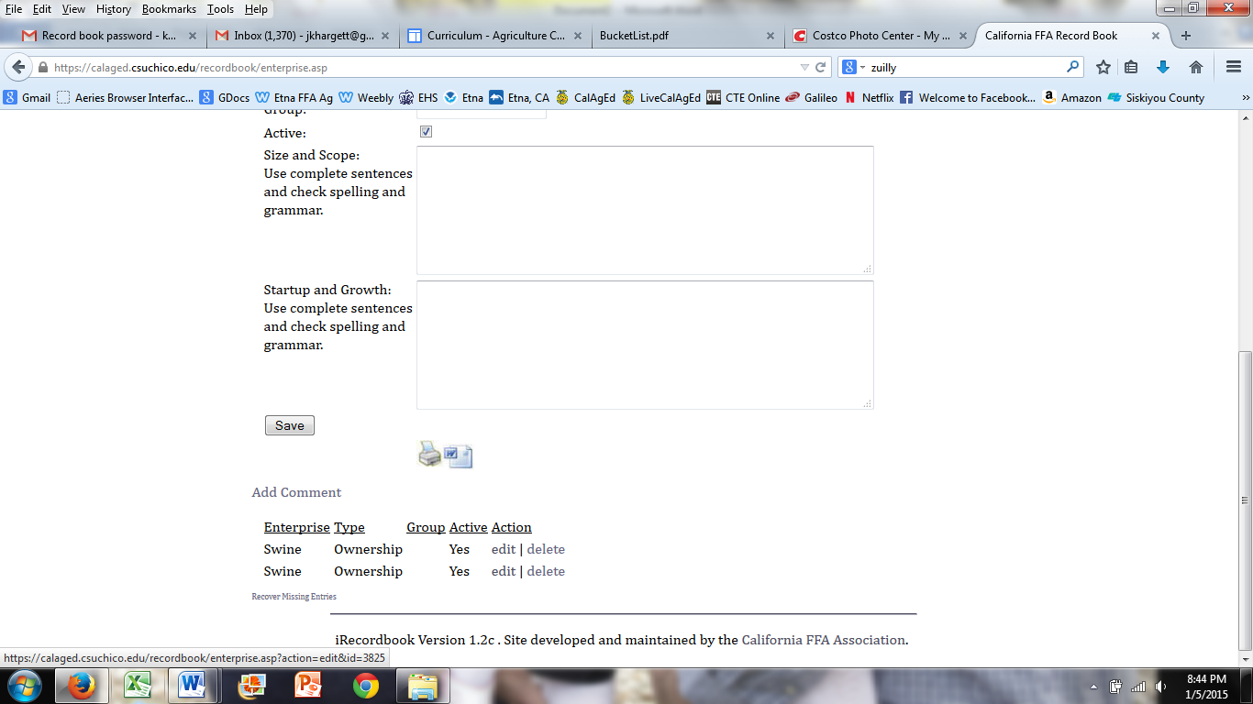
Click on edit
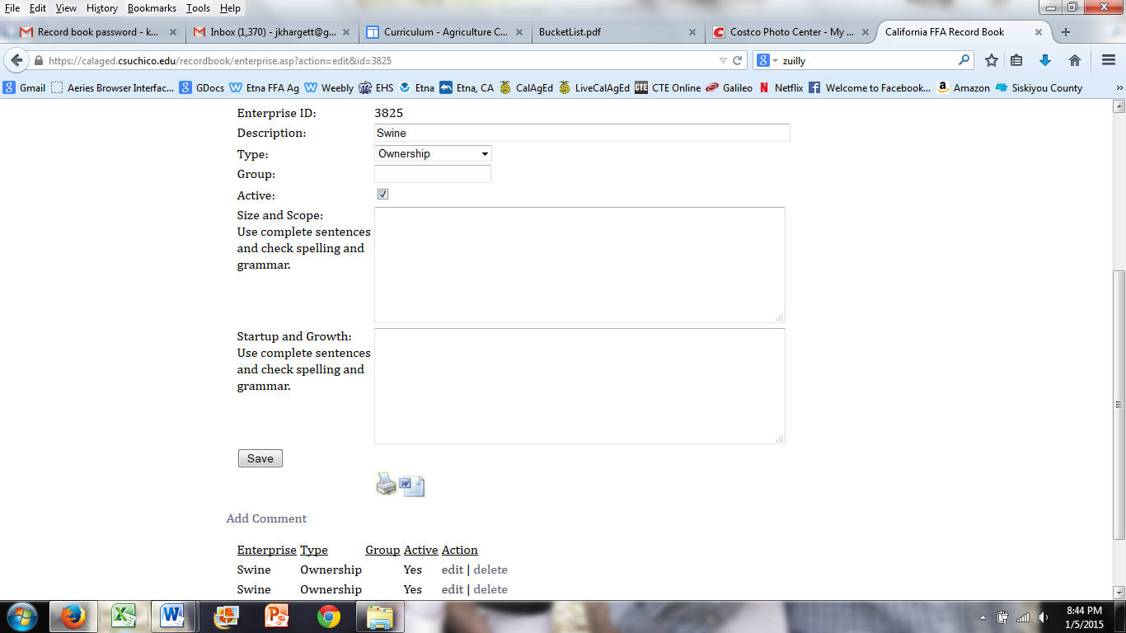
Fill in the questions above on all projects and show growth on each consecutive year.
Size is the number of animals, cords, etc. Scope is how broad or detailed is project. Startup is where did you get the money to start project. Growth is how has your project grown or changed.
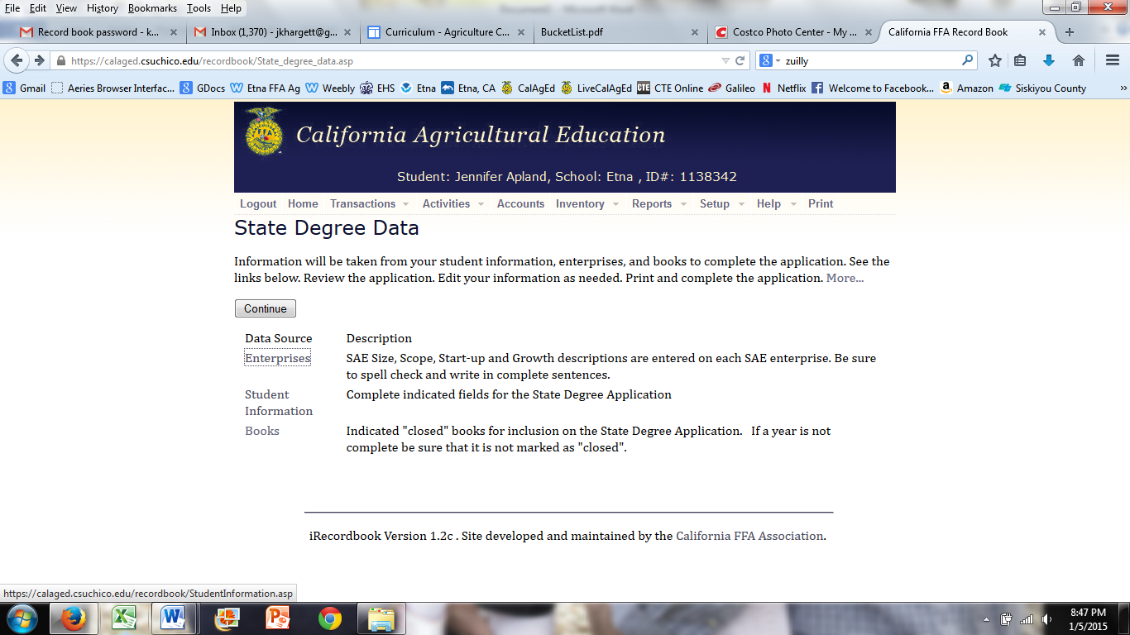
Click on student info
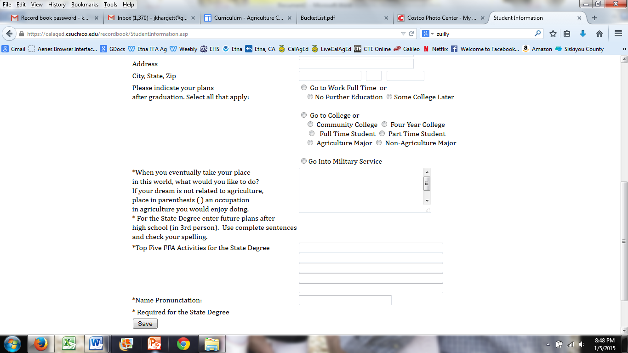
Fill in all information. The box with the side bar is your info for your plans after you graduate. Make sure you have 5 activities above the chapter level.
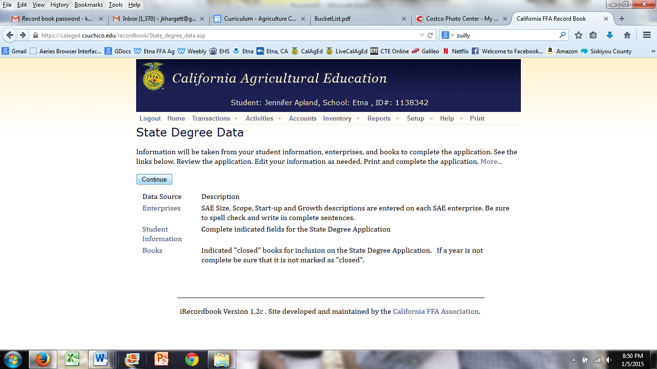
Click continue for the rest of the application
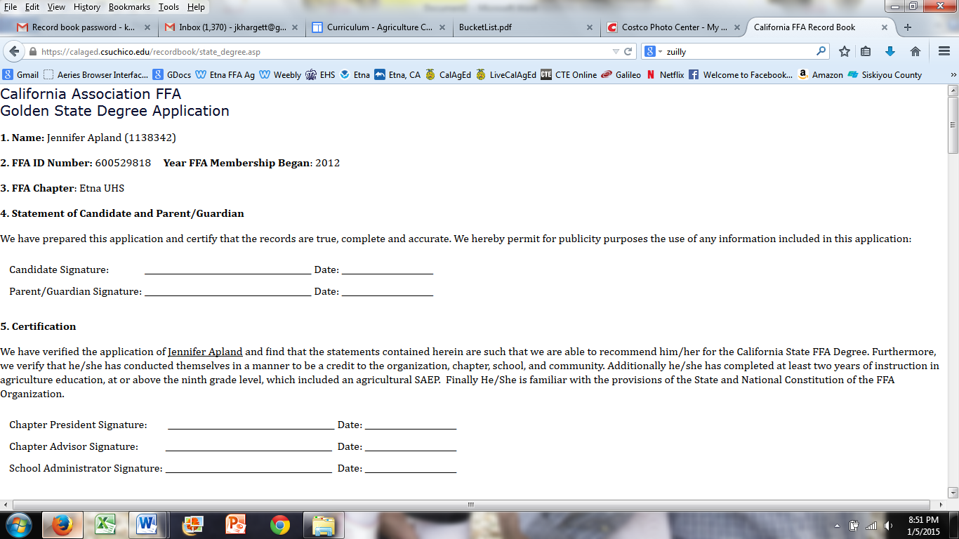
Review application with your teacher. Once it is approved print application, obtain signatures and return to your teacher.

