- Scientific Name: Stellaria media
- Common Name: Common Chickweed
- Location collected: EHS Campus
- Date collected: Sept. 3, 2013
- Main crops infested or damage potential: It can harbor several viruses and other pests that affect a variety of vegetable crops
- Type of habitat (native plant?): Yards, turf, gardens, landscaped areas, agronomic and vegetable crop fields, orchards, vineyards, grasslands, managed forests, nurseries, roadsides, and other disturbed places.

Table of Contents

Caryophyllaceae: Pink Family……………………………………….Page 1
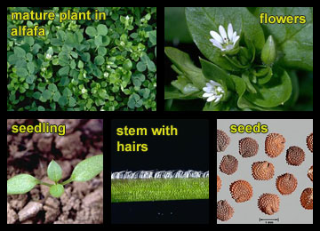

SEE SAMPLE BELOW

Common chickweed

Scientific name: Stellaria media (Pink Family: Caryophyllaceae)

Common chickweed is primarily a winter annual broadleaf in California, but in foggy coastal areas, it can survive year-round. Common chickweed is found throughout most of California, except in the Mojave Desert, up to 4300 feet (about 1300 m) and is especially common in lawns and landscaped areas. It inhabits agricultural land and other disturbed sites. It can harbor several viruses and other pests that affect a variety of vegetable crops. Many species of wildlife feed on its leaves and seeds.

Habitat
Yards, turf, gardens, landscaped areas, agronomic and vegetable crop fields, orchards, vineyards, grasslands, managed forests, nurseries, roadsides, and other disturbed places.

