Matching Match the appropriate symbol with the label it refers to:

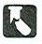
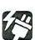
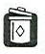
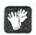
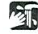
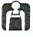
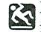
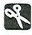
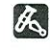
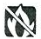
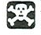
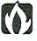

- ____ Safety Goggles
- ____ Laboratory Apron
- ____ Breakage
- ____ Gloves
- ____ Heating
- ____ Sharp Object
- ____ Electric Shock
- ____ Corrosive Chemical
- ____ Poison
- ____ Physical Safety
- ____ Animal Safety
- ____ Plant Safety
- ____ Flames
- ____ Fumes
- ____ Disposal
- ____ Hand Washing
- ____ No Flames

