Name: _______________________________________________ Period: 1 2 3 4 5 6

Earth Science - Unit 17 Study Guide

1) Define the following terms:

ozone –

conduction –

convection –

radiation –

scattering -

2) What the most abundant gas in the atmosphere?

3) What is the lowest layer in the atmosphere?

4) What layer (atmosphere) does most of the weather take place?

5) When is the autumnal equinox in the Southern Hemisphere?

6) What date does the Antarctic Circle have 24 hours of daylight?

7) What is true about equinoxes?

8) What % of the sun’s energy that reaches the Earth’s surface is reflected back into the atmosphere?

9) What method of heat transfer does the earth receive from the sun?

10) How much of the Sun’s energy is absorbed by the Earth’s atmosphere and clouds without reaching the Earth’s surface?

11) What are the two most important heat-absorbing gases in the lower atmosphere?

12)
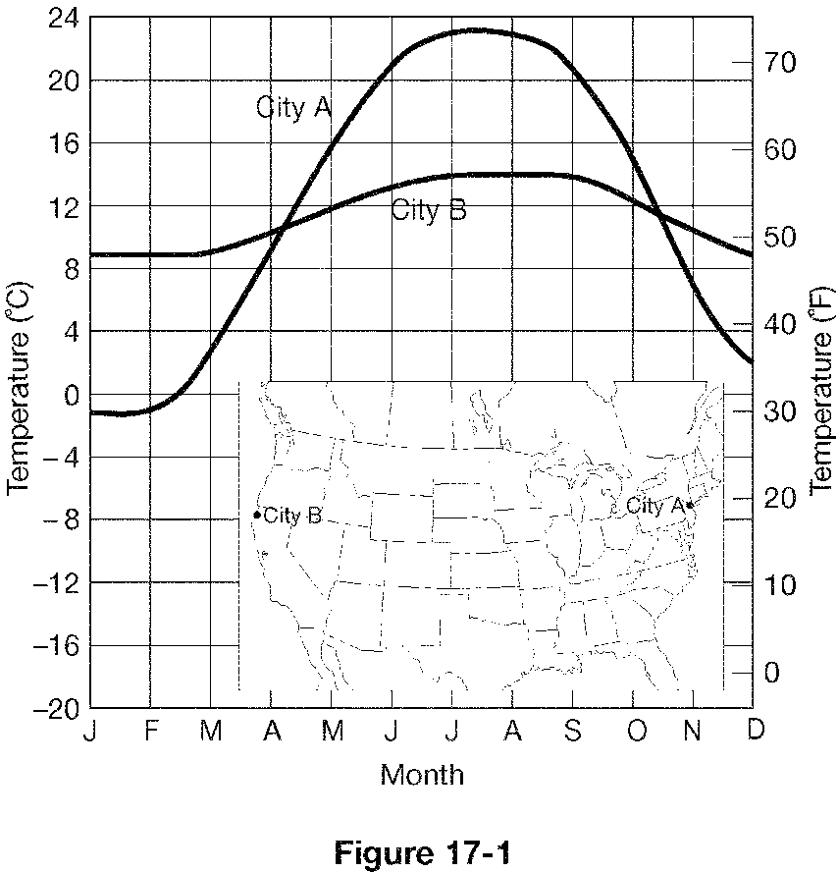

Based on Figure 17-1, what is likely true of City A?

a. It is located on a windward coast. c. It is located on a leeward coast.
b. It is farther north than City B. d. It has cool summers and mild winters.

Based on Figure 17-1, what is likely true of City B?

a. Its temperature is strongly influenced by prevailing ocean winds.
b. It has cool summers and mild winters.
c. It is located on a leeward coast.
d. both a and b

